Abstract
This document provides information about standardizing the screens in the APLLIB system.
APLLIB Screen Standardization

Table of Contents
1 Introduction 2
1.1 Purpose 2
1.2 Intended Audience 2
1.3 Scope 2
1.4 Definitions and Acronyms 2
2 Reasons for Screen Standardization 3
2.1 Standards based on IBM Defaults 4
3 Screen Standards 5
3.1 Screen Headers 5
3.2 Screen Content 6
3.2.1 Example Screens 7
3.3 SFL Layout 9
3.3.1 SFL Options 9
3.3.2 SFL Headers 9
3.3.3 SFL Examples 9
3.4 Command Keys 10
3.5 Windows 12
3.6 Window SLF’s 12
3.7 Error Messages 13
4 Revision History 14

Introduction
This document provides information about standardizing the screen on the AS400 system.

Purpose
This document was created to assist AS400 developers with standardizing screens on the AS400. Screen standardization assists with creating a better end user experience(UX). It does this by assisting with learnability of the system. This follows the HCI principal of learnability.

Intended Audience
The I/T department at Arrowhead Winch.

Scope
This document covers specifics about the screen layout for AS400 interactive programs at Arrowhead Winch. It is not meant to be a programming guide. It can only be applied to screens designed by Arrowhead Winch IT, meaning it should not attempt to be applied to programs provided by third parties.

Definitions and Acronyms
APLLIB – A library containing programs and tools to assist with application development. It includes many features for creating a data dictionary, SQL tables and programs. As well as tools for working with query output and general development short cuts.
UX – User experience
UI – User interface
HCI – Human computer interaction.

Reasons for Screen Standardization
HCI is the study of human computer interaction. One of the principles of HCI is learnability. From Google’s AI at the time of writing, it is defined as follows.
Learnability in Human-Computer Interaction (HCI) refers to the ease with which new users can begin effective interaction and achieve maximum performance with a system, requiring minimal training. It is a core component of usability, aimed at making systems intuitive, reducing user cognitive load, and enabling rapid proficiency.
Key Principles to Support Learnability
These principles enhance how easily users can learn and master an interface:
- Predictability: Users can determine the outcome of a new interaction based on their past history with the system.
- Synthesizability: Users can assess the effect of past operations on the current system state, allowing them to understand the results of their actions (e.g., showing a file move operation).
- Familiarity: The interface leverages the user's prior knowledge and experience from real-world or other computer-based domains.
- Generalizability: Users can extend knowledge of specific interaction techniques to other similar applications or situations.
- Consistency: Similar input-output behavior or tasks are handled in similar ways throughout the system.
Measuring Learnability
Learnability is measured by assessing how quickly a user can perform tasks on the first attempt and how many repetitions are required to reach peak efficiency. It is often analyzed using learning curves to determine when users reach a, "plateau," of proficiency.
Standardizing screen layouts and interactions support all the principles listed above.

Standards based on IBM Defaults
Since many users will jump in and out of system screens. Many of these standards are based on IBM defaults. This provides many benefits. Not only does it promote good HCI for switching between IBM screens and Data3 screens, but many third-party applications use IBM standards as well. This creates a more comprehensive user experience within the AS400.
IBM defaults are followed in the command keys, SFL options, and some coloring and screen layout standards.

Screen Standards
The following sections describe the screen headers based on the different sections of the screen.

Screen Headers
The screen headers provide some basics that should be included on every screen. This provides the user and IT help with the following information.
- Date and Time
- Environment – This comes from a data area in the data library. It informs the use of what system they are working on.
- Program Name – This should be a field set in the program from the SDS. It should not be a text literal, or it will often not get updated. This assist IT in providing help to a user if a screen shot is sent in with a help request.
- Program Mode – Each program has a mode. It may be hardcoded to inquiry or update. Some programs allow the mode to be changed. If so, it should be a field so it changes as the mode does.
- Program Title – This is the title of the program. It informs the user of what the program does.
- User Profile – This is just the jobs user. It assists IT with figuring out what user is running the program if a screen shot is sent in.
This is what the program header should look like:
The following is an example of the DDS code to create the header rows. You can copy this directly into the DSPF source.
A 1 2DATE
A EDTWRD('0 / / ')
A 1 11TIME
A EDTWRD(' 0: : ')
A ENVIRONMNT 40A O 1 21MSGID(AAA 0000 ENVIRONMNT)
A PGMNME R O 1 70
A MDE R O 2 2
A 2 30'Dictionary Master List'
A COLOR(WHT)
A 2 70USER

Screen Content
This section describes how content should be laid out and displayed on a screen.
Display/Output Fields
User entered data should be in white. Use High Intensity to create white as it tends to be bold even if the user has changed their color scheme. In the old days it was bold on monochrome displays as well, this is not really an issue anymore.
Input Fields
Input fields should have column separators and underlines. This makes them till and the underlines are easier to see than just the column separators. This should be defined as the default at the top of the DSPF, before the first record. It looks like this in DDS.
A CHGINPDFT(CS UL)
Options Text
This is the text that shows the users what options are available for the field. It should be after input fields and be in the default color (green normally).
It should also include the date format for any date field.
In the following example, the options text is the (Yes/No) part.

Promptable Fields
Promptable fields are fields the user can use the prompt key (F4) in to select the value from a list. All promptable fields should be followed with a question mark. See image in the Options Text section for an example. The ? should be hidden if the screen is in display only mode.
Screen Layout
In general data should start at the top of the screen. If possible, leave one blank line after the second header row before starting the data.
Data should be aligned in columns and in sections. There can be more than one column in some sections. Header text should be left justified and aligned with in a section. Data fields should be left justified and aligned to the right of their header text.

Example Screens
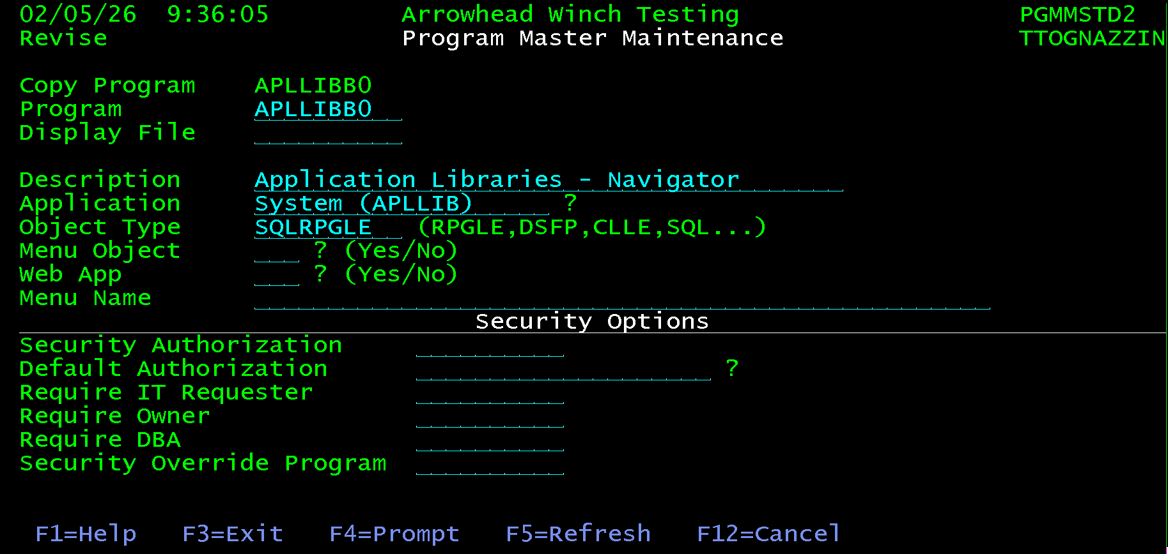
Notice that the content is broken out into 3 sections. Each section has both the field text and fields left aligned.
The following is the same screen in view mode. The ?’s should not be there, nor should the F4=Prompt function key.
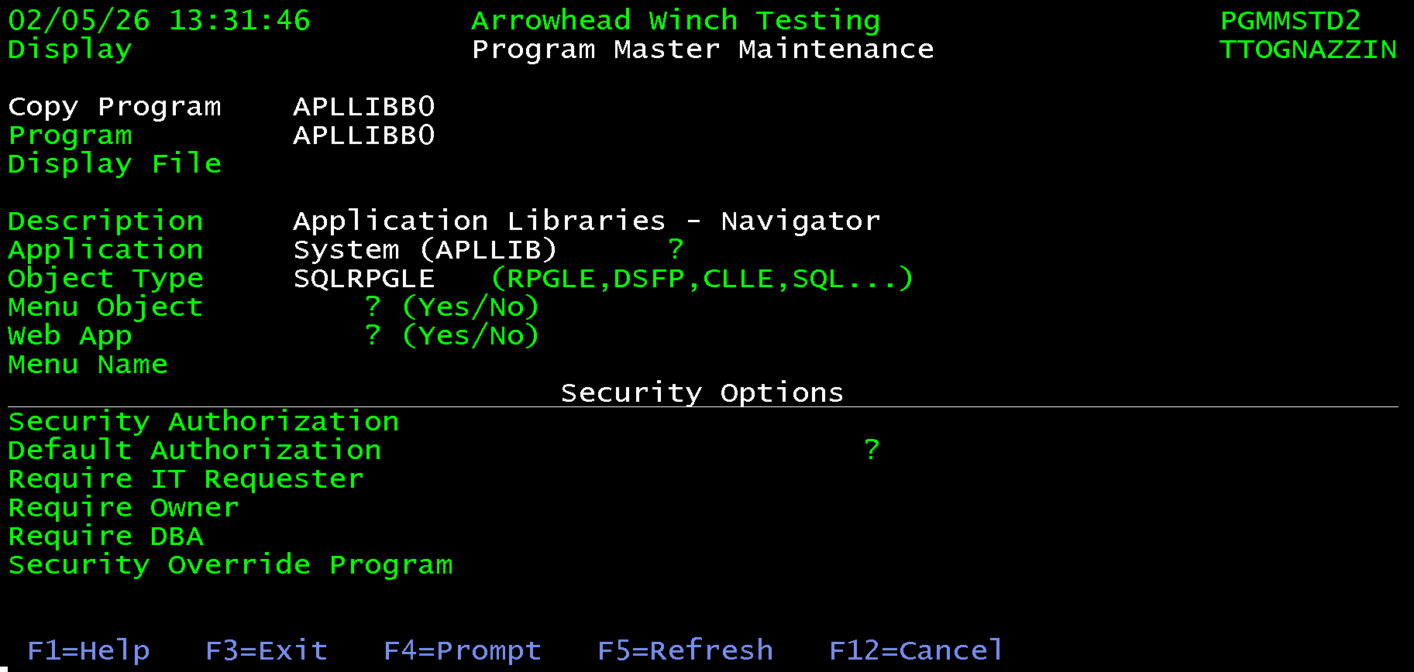

While following screen is a little messy as the periods should not be used, it shows how different screen sections can have different columns and alignment.
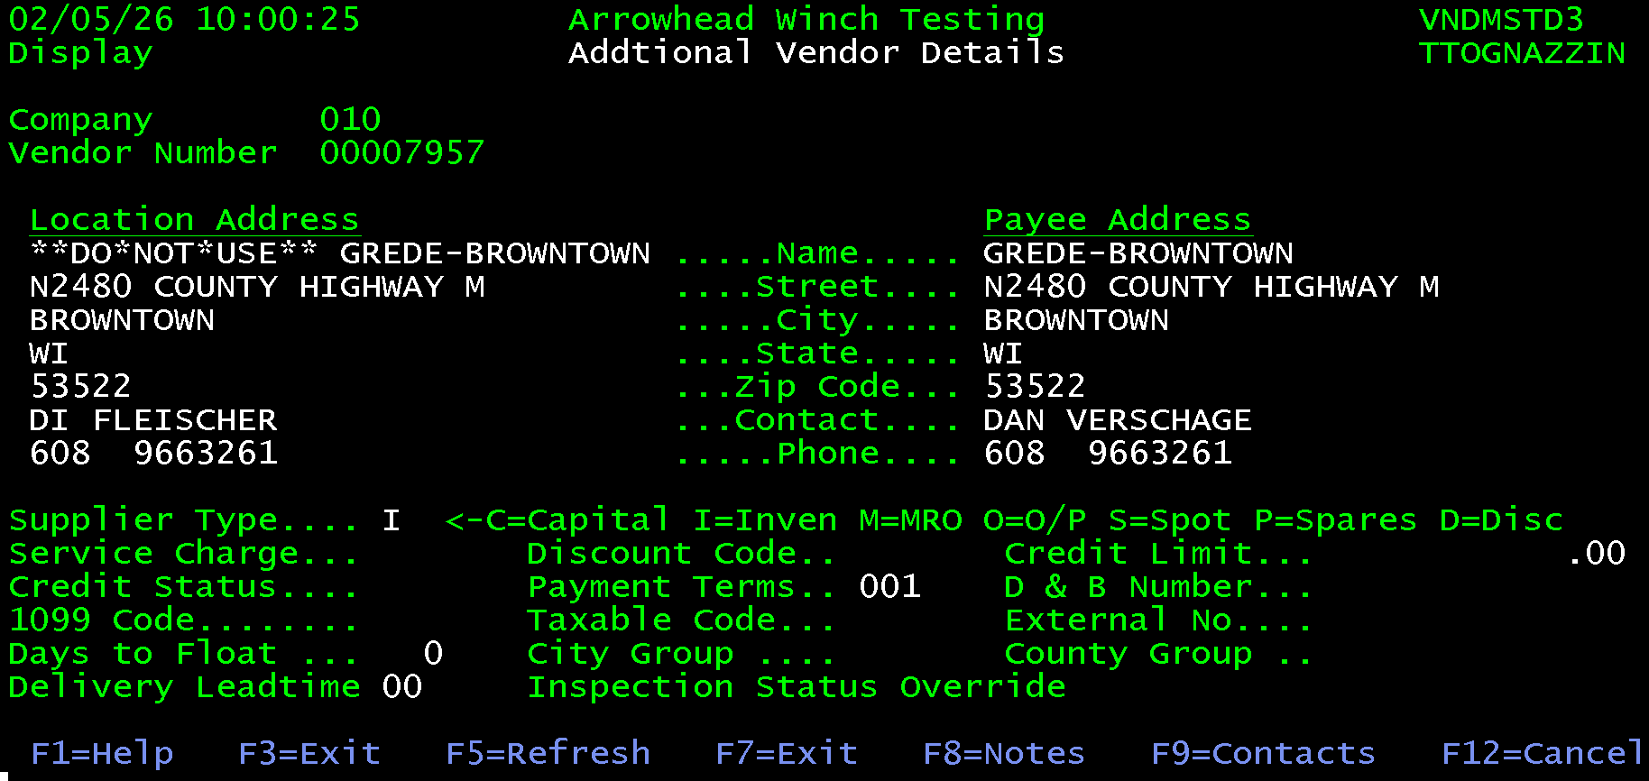
Notice that there are three screen sections, each separated with a blank line.
The first section only has one column. The fields and text are left justified and aligned. However, the data fields should be in high intensity and are not.
The second section has 2 columns. The text fields are not correct, but each column is left justified and aligned.
The final section has three columns, all left justified and aligned. The option text for the Supplier Type runs over all three columns. If there was room on the screen, the option type should have been made into its own section by adding a blank line after it. This is an example of an acceptable deviation based on available room.

SFL Layout
SFL screens should use the same headers as other screens. Content before the header SLF should follow the same standards listed in the screen layout section. The SFL screen adds a list of SFL options, SFL headers and the SFL body. A SFL footer should be included that has the command keys following the standards in the Command Keys section of this document.

SFL Options
SFL options should be shown in blue. They should be listed horizontally above the SFL headers. They should be in this format 5=View. The option number followed by the equal sign, followed by the option text. There should be no spaces around the equal sign. The option text should have the first letters capitalized.

SFL Column Headers
SFL should have column headers in high intensity and underlined.

Optional Position to Row
If feasible there should be a position to row at the top of each SFL. Entering a value into this row will sort the SFL by that column and position to the entered value.

SFL Example
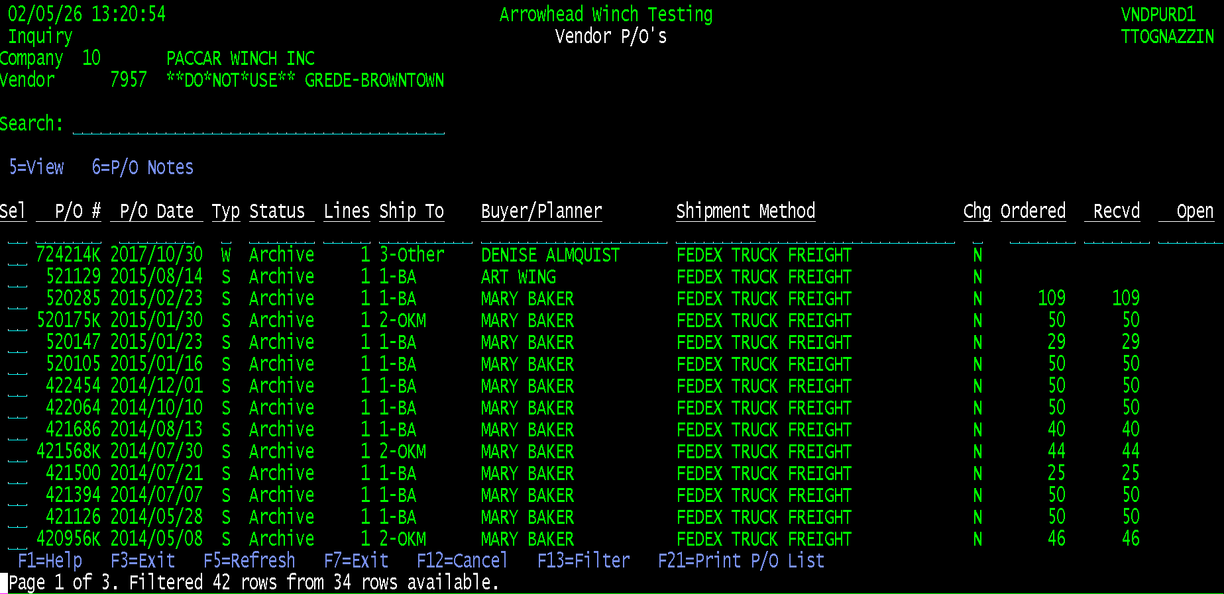

Function/Command Keys
General Rules:
- Function keys should be included on the bottom of every screen for all available functions. They should be in blue.
- Try to include 3 spaces between each function key.
- The keys should not overlay the message SFL.
- SFL and SFL windows should also show the function keys at the bottom.
- The keys should be displayed like this: F3=Exit. The function key followed by the equal sign followed by its description. There should be no spaces around the equal sign. If the description has multiple words, each one should be capitalized.
- Keys should be listed in the order of the key number if possible.
- Commonly used command keys should be F12 or lower to make using them easier. Try to use keys above F12 only for seldom used functions.
The following list of command keys are static; they should never be used for anything else.
Key | Value | Comment
F1 | F1=Help | Should be on any screen with help defined
F3 | F3=Exit | Should be on every screen
F4 | F4=Prompt | Only include if there is a promptable field on the screen.
F5 | F5=Refresh | Should be on every screen
F12 | F12=Cancel | Should be on every screen
F23 | F23=More Options | Used on SFL screen where all options do not fit on one line
F24 | F24=More Keys | Used if all command keys do not fit on one line.
All other command keys can be used as needed, but the following are some standards that should be adhered to if applicable.
Key | Value | Comment
F6 | F6=Add | Used to add a new entry to list screen
F11 | F11=Show Inactive | Used to toggle between showing active and inactive entries in a SFL.
F13 | F13=Filter | Used on a SFL screen to display a filter screen for the list.
F21 | F21=Print List | Used to print the results on a SFL list screen.

Windows
Use of windows should be limited. In some cases, they make sense, but only where needed.
Good uses include:
- Warning message
- Confirmation prompts
- More Details for a SFL entry
- Single value prompts
Most of the time it is just better to display a new screen instead of using a window.
Windows should use the default border, do not override the window border attributes.
All usable function keys should be listed at the bottom of the window.
Screen headers need to be augmented. If there is enough room to display them all, a window should not be used. Still always include a centered title. If the window is in a different program than the screen it is overlaying, then it should include the program number. When a window is displayed, the previous screens headers should still be visible, so the date, time, environment and user information does not need to included in the header of the window.

Window SLF’s
Window SFL’s need to follow all the rules of both windows and SFL’s. This includes having command keys at the bottom.

Error Messages
Error messages should be displayed in a MSG SFL on the bottom of the screen.
The following is what this looks like in DDS. There are examples for 80 and 132 width screens. The examples can be copied directly into a DDS file. The only difference is the value in the SFLMSGRCD.
80 Width Example
*
*------------------------------------------------------------------------
A R MSGRCD TEXT('MSG SFL RECORD')
A SFL SFLMSGRCD(24)
A MSGKEY SFLMSGKEY
A CALLSTK SFLPGMQ
*
*------------------------------------------------------------------------
A R MSGCTL TEXT('MSG SFL CONTROL')
A SFLCTL(MSGRCD) SFLSIZ(10)
A SFLPAG(1) SFLDSPCTL SFLDSP SFLINZ
A N99 SFLEND
A CALLSTK SFLPGMQ
132 Width Example
*
*------------------------------------------------------------------------
A R MSGRCD TEXT('MSG SFL RECORD')
A SFL SFLMSGRCD(27)
A MSGKEY SFLMSGKEY
A CALLSTK SFLPGMQ
*
*------------------------------------------------------------------------
A R MSGCTL TEXT('MSG SFL CONTROL')
A SFLCTL(MSGRCD) SFLSIZ(10)
A SFLPAG(1) SFLDSPCTL SFLDSP SFLINZ
A N99 SFLEND
A CALLSTK SFLPGMQ

Revision History
Version | Approved By | Revision Date | Description of Change | Author
1.0 |  | 2026/02/05 | Initial Creation | Tim Tognazzini

